THE BIOPSYCHOLOGICAL BASICS OF LIFE IN EDUCATION AND HEALTH

2nd International Symposium of the
Life Research Network
Bionet
art meets science

24–26.10.2014 in RIGA (Latvia)

With medical, biological, psychological, educational scientists and experiential research (Biodanza)
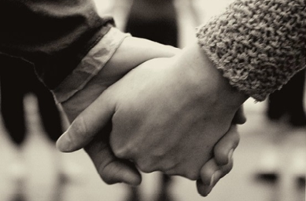
Science is art (Albert Einstein) and
art is experience.
Science is not a question of powerful institutions, positions or highly ranked publications. It is first of all a question of curiosity, to see and to discover deeply this world. The BIOnet idea is to bring together researchers who experience intuitively life (e.g. Biodanza) and scientists, who measure and describe life. The scientist inspires the artist and the artist stimulates the scientist. In this way BIOnet integrates body and mind and creates a new form of scientific encounter. It can be done worldwide and is the new paradigm of science.

A new form of scientific encounter

www.bionet.name
Bionet = new form of Biodanza encounter
A scientist who is able to dance, paint or describe life with poetry and a dancer who is able to understand empirical science are both complete.

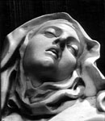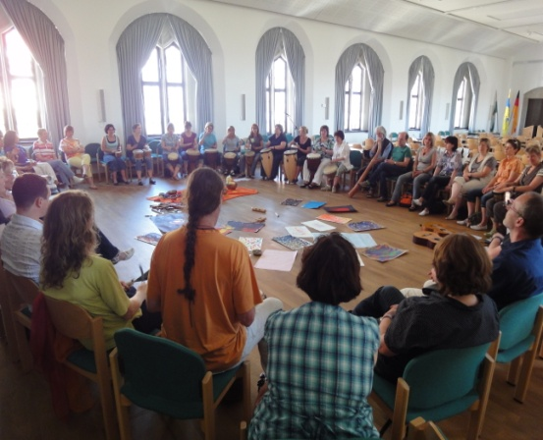

KEYNOTE speakers
We define 3 areas for BIOnet and invited keynote speaker from 8 countries:
Area 1: Biological basics of life
Prof Dr U. Sack (Germany TRM Uni Leipzig)
Music and the immune and hormonal systems
Dr U. Balzer (Germany Humboldt Uni)
Chronobiological effects of paintings and space
Dr V. Savkovic (Germany TRM Uni Leipzig)
Stem cell research and biological dogmas
Assoc Prof Dr Daina Voita (RTTEMA Latvia) Nonmedical pain management
Area 2: Psychological and educational
bases of life
Prof Dr G. Svence (RTTEMA Latvia)
The newest in positive psychology
Prof Dr M. Stueck (DPFA-Uni Germany) Biodanza-meditation research, Stress Lab research
Prof Dr P. Tofts (England, Brighton): Bionet-Journal Editor (UK)
Yumi Lee (South Korea, Taipeh): Psychological interventions for trauma therapy
Area 3: New approaches to Life Science:
EXPERIENCE – Research
Dr A.Villegas (Spain, Biodanza Latvia)
Moviepsychology and experience
M. Pöllmann (Austria Biodanza Vienna). Effect of trance induction
Dr Wiryono Raharjo (Islam Uni Indonesia) Sacred and holy places in daily architecture

Bionet = art meets science
when nonlinear EXPERIENCE and linear EMPIRICAL SCIENCE meet, life begins to grow in its complete form (Marcus Stueck).

CONFERENCE VENUE: Riga teacher training educational management academy, Imantas 7. linija 1, Riga, Latvia.

SCIENTIFIC BOARD:
Prof M.Stueck, Prof D.Voita, Dr A.Villegas,
Prof G.Svence, Prof Dr med U.Sack, A.Bukulite

Organisational BOARD:
Prof M. Stueck, Prof D. Voita,
Prof G. Svence, Dr A. Villegas
Vineta Grievza, Saiva A. Bukulite,
E. Valeviča, A. Kaulina

CONFERENCE FEE:
Day 1&2: 70 E (students 20E); Day 3: extra
"Swedbank" Kods: HABALV22
IBAN konts: LV67HABA0551009558549

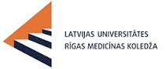
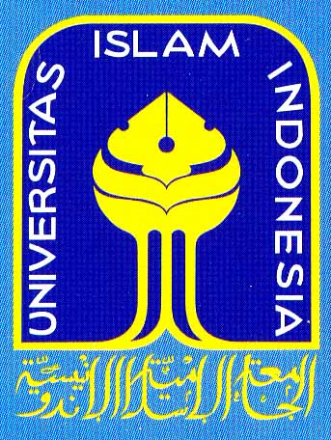
BIONET-Cooperation Partners:

Programme

DAY 1 (Friday 24.10.2014):
10:00 Opening What is BIOnet?
Prof Dr M. Stueck, Dr A. Villegas,
Prof G. Svence, Assoc Prof Dr D. Voita

10:10 Introduction to the BIOnet journal.
Prof Dr M.Stueck, Prof Dr Paul Tofts

10:15 – 10:45 Area 1: Basic nonmedical pain intervention Assoc Prof Dr D. Voita

Relaxation (Area 3 - methods): Trailer

11:00 – 11:30 Area 1 The newest in chronobiology and art Dr H.-U.Balzer

Relaxation (Area 3 - methods): Power Nap

11:45 – 12:15 Area 2: Scientific effects of experiential phenomena Prof Dr M.Stueck

BREAK Poster Session Areas 1,2
Artists-Exhibition INWORLD Area 3

Workshops:
13:15 – 14:15 Area 1 – Medicine & Biology
(Chair: Prof D.Voita)

Please apply with contributions

14:45 – 16:30 Area 3 – Experiential science (Biodanza) (Chair Prof Dr M.Stueck)
Please apply with contributions

17:00 – 18:00 Area 2 – Psychology, Education, Anthropology Chair; Prof Dr G.Svence

Please apply with contributions

18:00 – 19:00
BIONET – Dinner & Latvian culture

19:00-20:30 Biodanza VIVENCIA Area 3
The Power of TRANCE M. Poellmann
DAY 2 (Saturday 25.10.2014)
10:00 – 10:30 Area 2: Sacred and holy places in daily architecture Dr. Wiryono Raharjo (Islam Uni Indonesia)

Relaxation (Area 3 - methods): Music

10:45 – 11:15 Area 2: Positive psychology and biodanza Prof Dr Guna Svence

Relaxation (Area 3 - methods): Yoga on chair

11:30 – 12:00 Area 1: stem cell research and biological dogmas Dr V. Savkovic

BREAK Poster Session Areas 1,2
Artists-Exhibition INWORLD Area 3

12:45 – 13:15 Area 1: Cell research and music Prof Dr U.Sack
13:15 – 14:15 Discussion about cooperations in interdisciplinary research projects

Discussion about concrete cooperations in interdisciplinary research project IDENTITY (biopsychological processes of human identity) within BIOnet

14:30–16:00 BIODANZA-Vivencia Area 3
Biodanza the dance of life in Latvia
Anette, Diana, Kristiana, Vineta and others

BREAK Poster Session Areas 1,2
Artists-Exhibition INWORLD Area 3

17:00 – 18:30 Final presentation biodanza teachers Latvia

19:00–21:00 Biodanza VIVENCIA Area 3
Dr A. Villegas
Experience as a research method
All contributions can be published in the peer
reviewed journal BIONET.
www.bionet.name
DAY 3 (Sunday 26.10.2014 10:00 – 17:00)

POST CONFERENCE workshop

EXTRA: 70 Euro: pay cash on this day

M.Stueck & Alejandra Villegas

Film-Psychology and BIODANZA
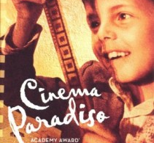
This very special workshop is based on 2 levels – one is to see scenes from the Italian movie Cinema Paradiso.
Director Giuseppe Tornatore made the film in 1988. In Level 2 Alejandra Villegas and Marcus Stueck, the directors of the Biodanza-School Latvia, combine the feelings of the moving life of a fatherless boy who loves movies with BIODANZA-experiences. This project was in Germany a big success.

Alternative: Sunday = Guided Tour RIGA
START: 10:00 NB-Hotel Sokol Street Riga

Please send your application for contributions (presentations, posters, Biodanza-Vivencias) to

CONTACT
E-mail: guna.svence@rpiva.lv
Department of Research and Innovations RTTEMA
Phone: +371 67 808 124, +371 67 860 665
Fax: +371 67 860 665
Bionet
art meets science

www.bionet.name

